Learn
1.
1.

2.
1.

2.
1.

2.

3.

4.
1.

2.
1.

2.
1.

2.
1.

2.
1.

2.
1.

2.
1.

2.

3.
1.

2.
1.

2.

3.

4.

5.
HELLO WORLD: JAVA

Introduction to Java
Welcome to the world of Java programming.
Programming languages enable humans to write instructions that a computer can perform. With precise instructions, computers coordinate applications and systems that run the modern world.
Sun Microsystems released the Java programming language in 1995. Java is known for being simple, portable, secure, and robust. Though it was released over twenty years ago, Java remains one of the most popular programming languages today.
One reason people love Java is the Java Virtual Machine, which ensures the same Java code can be run on different operating systems and platforms. Sun Microsystems’ slogan for Java was “write once, run everywhere”.
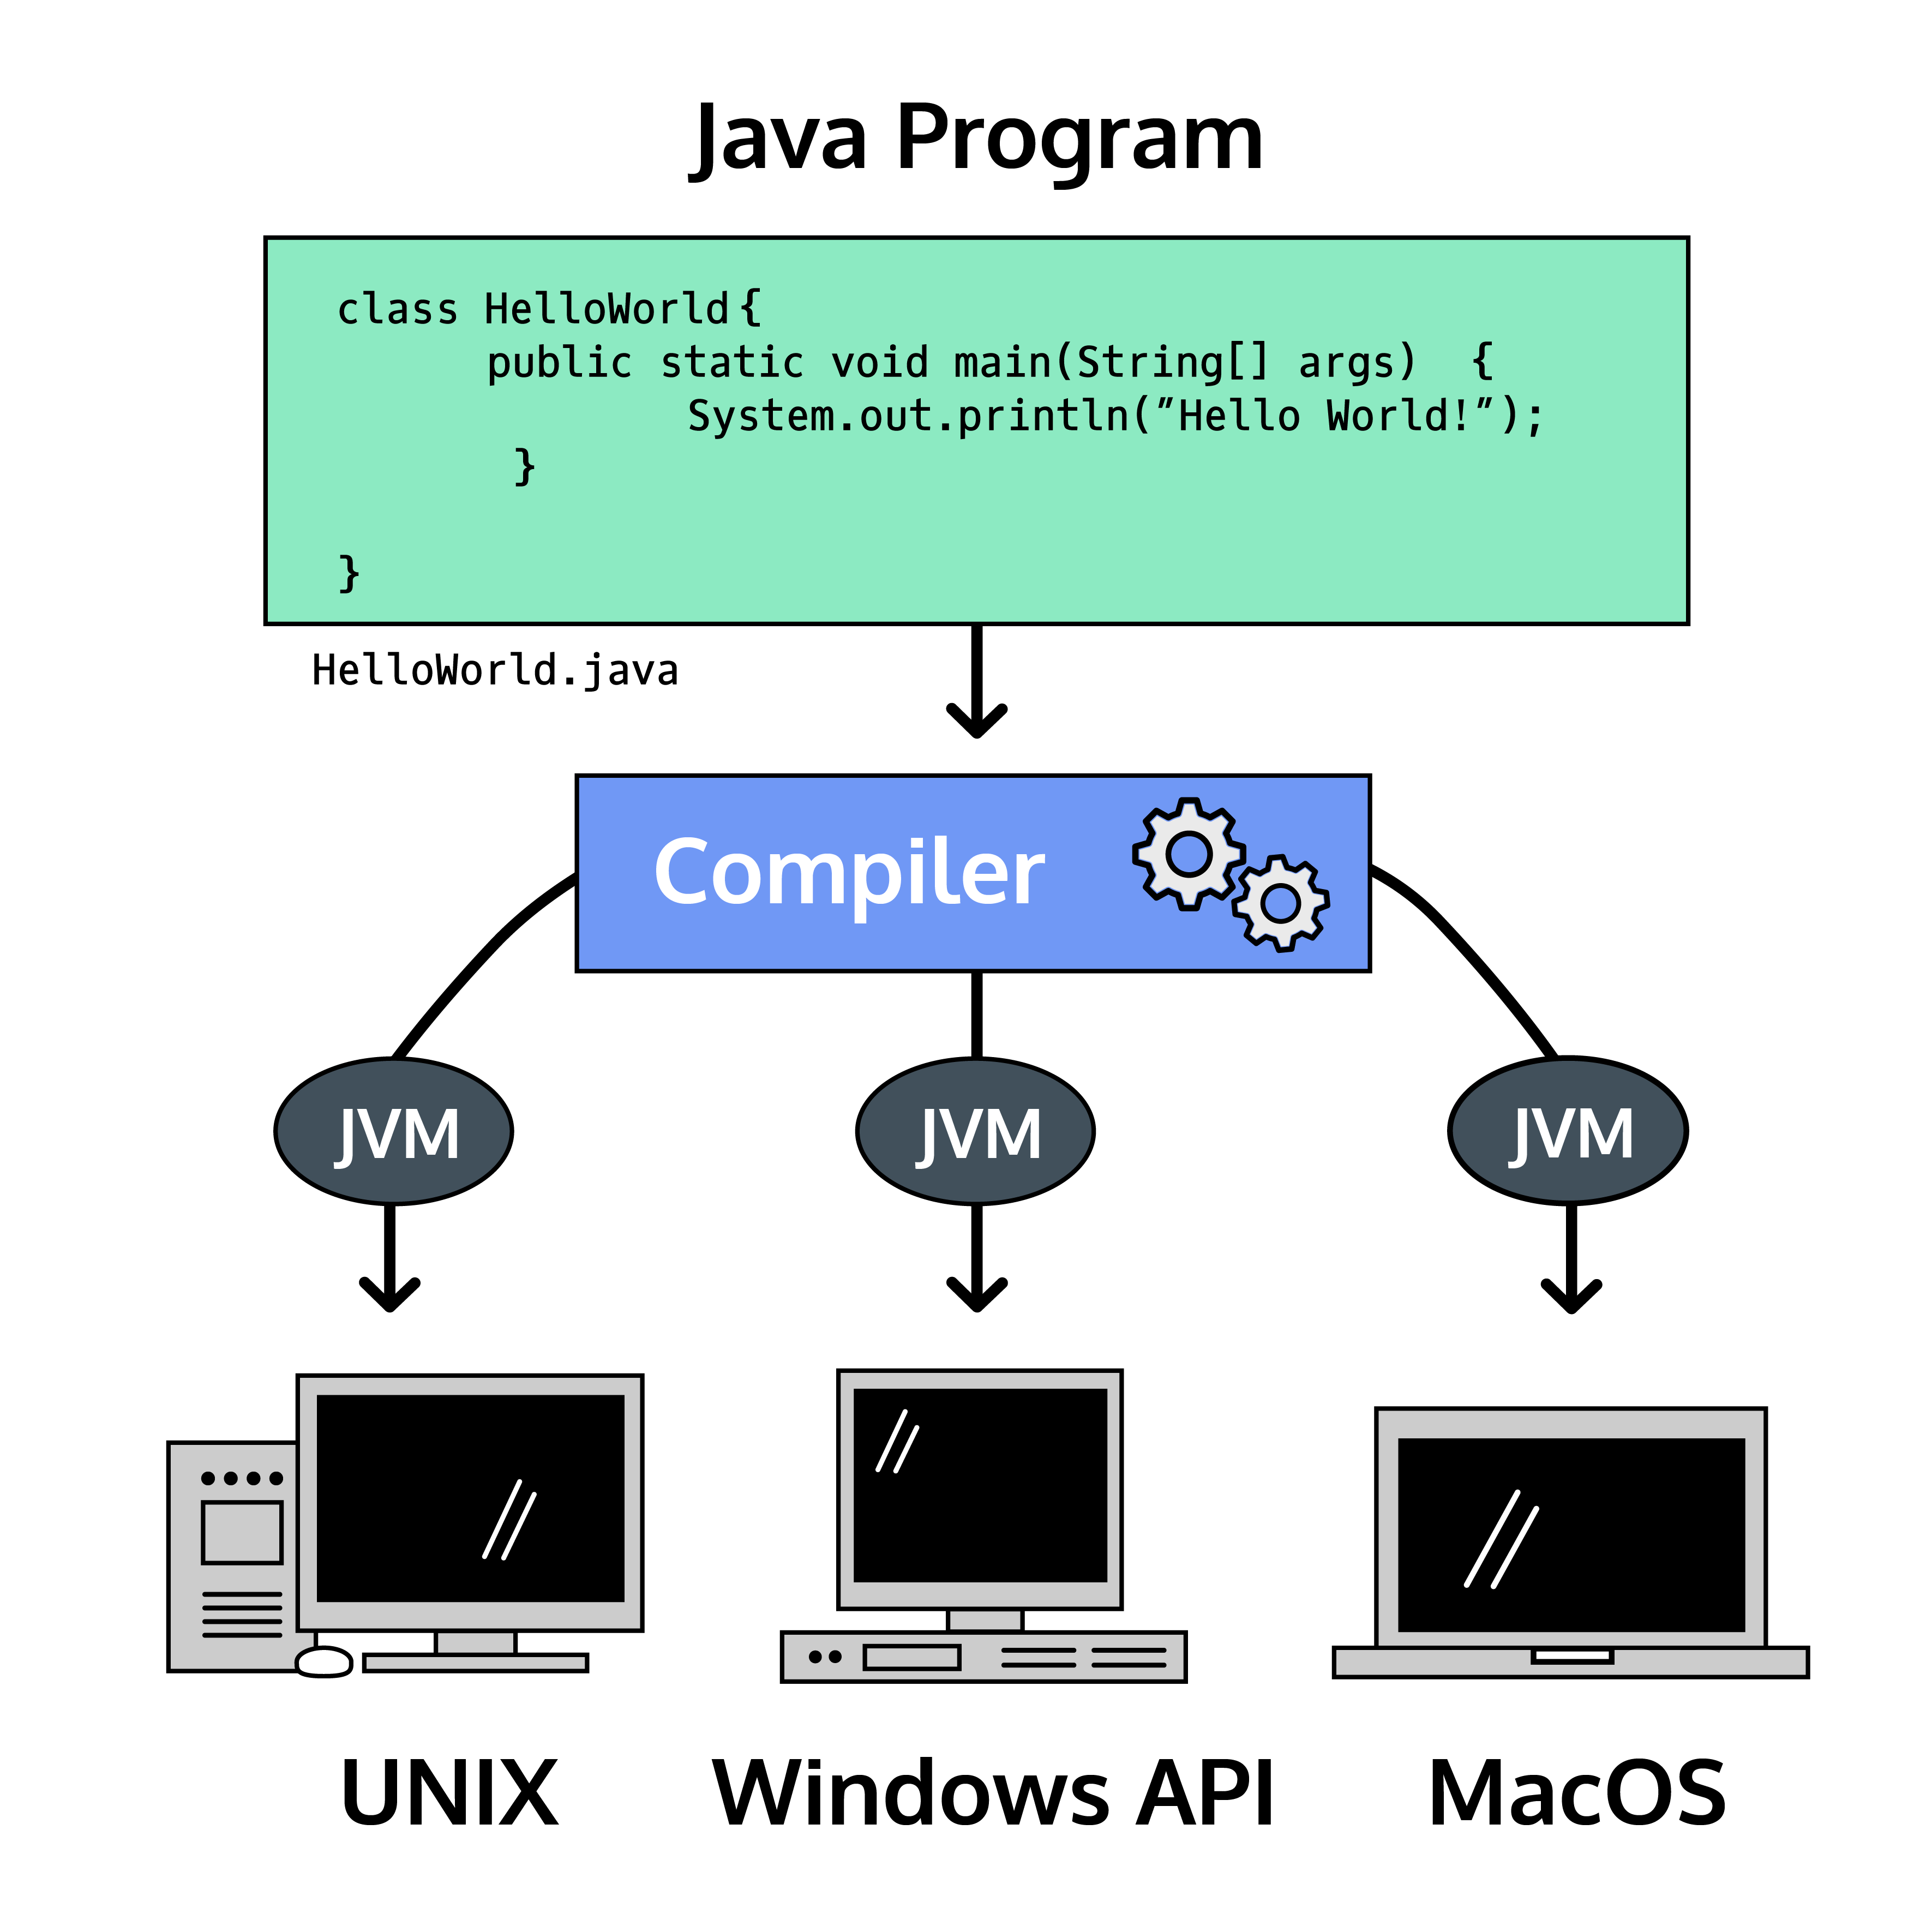
You’re interacting with a system using Java multiple times a day. As of 2019, 88% of smartphones run on Android, the mobile operating system written in Java!
Programming languages are composed of syntax, the specific instructions which Java understands. We write syntax in files to create programs, which are executed by the computer to perform the desired task.
Let’s start with the universal greeting for a programming language. We’ll explore the syntax in the next exercise.
Instructions
You’re looking at a computer program written in Java.
Run the code in the text editor to see what is printed to the screen.
--start--
public class HelloWorld {
public static void main(String[] args) {
System.out.println("Hello World!");
}
}
--end--

Learn
HELLO WORLD: JAVA

Hello Java File!
Java runs on different platforms, but programmers write it the same way. Let’s explore some rules for writing Java.
In the last exercise, we saw the file HelloWorld.java. Java files have a .javaextension. Some programs are one file, others are hundreds of files!
Inside HelloWorld.java, we had a class:
public class HelloWorld {

}
We’ll talk about classes more in the future, but for now think of them as a single concept.
The HelloWorld concept is: Hello World Printer. Other class concepts could be: Bicycle, or: Savings Account.
We marked the domain of this concept using curly braces: {}. Syntax inside the curly braces is part of the class.
Each file has one primary class named after the file. Our class name: HelloWorld and our file name: HelloWorld. Every word is capitalized.
Inside the class we had a main() method which lists our program tasks:
public static void main(String[] args) {

}
Like classes, we used curly braces to mark the beginning and end of a method.
public, static, and void are syntax we’ll learn about in future lessons. String[] args is a placeholder for information we want to pass into our program. This syntax is necessary for the program to run but more advanced than we need to explore at the moment.
Our program printed “Hello World” with the line:
System.out.println("Hello World");
println is short for “print line”. We’ll use System.out.println() whenever we want a program to write a message to the screen.
Instructions
The text editor has a file, HelloYou.java, that contains a HelloYou class with a main() method.
Inside main(), add a statement which prints Hello someName!, with your name replacing someName.
For example, my program would print Hello Patrick!.

Learn
HELLO WORLD: JAVA

Commenting Code
Writing code is an exciting process of instructing the computer to complete fantastic tasks.
Code is also read by people, and we want our intentions to be clear to humans just like we want our instructions to be clear to the computer.
Fortunately, we’re not limited to writing syntax that performs a task. We can also write comments, notes to human readers of our code. These comments are not executed, so there’s no need for valid syntax within a comment.
When comments are short we use the single-line syntax: //.
// calculate customer satisfaction rating
When comments are long we use the multi-line syntax: /* and */.
/*
We chose to store information across multiple databases to
minimize the possibility of data loss. We'll need to be careful
to make sure it does not go out of sync!
*/
Here’s how a comment would look in a complete program:
public class CommentExample {
// I'm a comment inside the class
public static void main(String[] args) {
// I'm a comment inside a method
System.out.println("This program has comments!");
}
}
Comments are different from printing to the screen, when we use System.out.println(). These comments won’t show up in our terminal, they’re only for people who read our code in the text editor.
Instructions
The file Timeline.java has plain text information about Java.
Plain text facts aren’t valid syntax. We’ll use comments to avoid breaking the program.
Use the single-line comment syntax for the first fact.
Change this line into a comment:
Sun Microsystems announced the release of Java in 1995
Stuck? Get a hint
Our program is still broken!
Use the multi-line syntax to make these lines into a single comment:
James Gosling is a Canadian engineer who created Java while
working at Sun Microsystems. His favorite number is the
square root of 2!
You should still see You are a fun language! printed!

Learn
HELLO WORLD: JAVA

Semicolons and Whitespace
As we saw with comments, reading code is just as important as writing code.
We should write code that is easy for other people to read. Those people can be co-workers, friends, or even yourself!
Java does not interpret whitespace, the areas of the code without syntax, but humans use whitespace to read code without difficulty.
Functionally, these two code samples are identical:
System.out.println("Java");System.out.println("Lava");System.out.println("Guava");
System.out.println("Java");

System.out.println("Lava");

System.out.println("Guava");
They will print the same text to the screen, but which would you prefer to read? Imagine if it was hundreds of instructions! Whitespace would be essential.
Java does interpret semicolons. Semicolons are used to mark the end of a statement, one line of code that performs a single task.
The only statements we’ve seen so far are System.out.println("My message!");.
Let’s contrast statements with the curly brace, {}. Curly braces mark the scope of our classes and methods. There are no semicolons at the end of a curly brace.
Instructions
The LanguageFacts.java file prints information about Java to the screen.
Unfortunately, the writer of the file has avoided using whitespace.
Make the file easier to read by adding a newline after each statement!
Stuck? Get a hint
Inside main(), add a new statement printing how you feel about coding.
Start the message with: “Programming is… “.
Remember to place a semicolon at the end of the statement!

Learn
HELLO WORLD: JAVA

Compilation: Catching Errors
Java is a compiled programming language, meaning the code we write in a .java file is transformed into byte code by a compiler before it is executed by the Java Virtual Machine on your computer.
A compiler is a program that translates human-friendly programming languages into other programming languages that computers can execute.

Previous exercises have automatically compiled and run the files for you. Off-platform development environments can also compile and run files for you, but it’s important to understand this aspect of Java development so we’ll do it ourselves.
The compiling process catches mistakes before the computer runs our code.
The Java compiler runs a series of checks while it transforms the code. Code that does not pass these checks will not be compiled.
This exercise will use an interactive terminal. Codecademy has a lesson on the command line if you’d like to learn more.
We compile a .java file with the terminal command: javac ExampleFile.java.
A successful compilation produces a .classfile: ExampleFile.class, that we execute with the terminal command java ExampleFile.
An unsuccessful compilation produces a list of errors. No .class file is made until the errors are corrected and the compile command is run again.

Learn
HELLO WORLD: JAVA

Compilation: Creating Executables
Compilation helped us catch an error. Now that we’ve corrected the file, let’s walk through a successful compilation.
As a reminder, we can compile a .java file from the terminal with the command: javac FileName.java.
If the file compiles successfully, this command produces an executable class: FileName.class. Executable means we can run this program from the terminal.
We run the executable with the command: java FileName. Note that we leave off the .class part of the filename.
Here’s a full compilation cycle as an example:
// within the file: Welcome.java
public class Welcome {
public static void main(String[] args) {
System.out.println("Welcome to Codecademy's Java course!");
}
}
We have one file: Welcome.java. We compile with the command: javac Welcome.java. The terminal shows no errors, which indicates a successful compilation.
We now have two files:
- Welcome.java, our original file with Java syntax.
- Welcome.class, our compiled file with Java bytecode, ready to be executed by the Java Virtual Machine.
We can execute the compiled class with the command: java Welcome.
The following is printed to the screen:
Welcome to Codecademy's Java course!

Learn
HELLO WORLD: JAVA

Java Review: Putting It All Together
In this lesson, we’ve started writing our first programs in Java.
We’ve also learned rules and guidelines for how to write Java programs:
- Java programs have at least one class and one main() method.
  - Each class represents one real-world idea.
  - The main() method runs the tasks of the program.
- Java comments add helpful context to human readers.
- Java has whitespace, curly braces, and semicolons.
  - Whitespace is for humans to read code easily.
  - Curly braces mark the scope of a class and method.
  - Semicolons mark the end of a statement.
- Java is a compiled language.
  - Compiling catches mistakes in our code.
  - Compilers transform code into an executable class.
Instructions
The text editor holds an empty file named Review.java. Fill it in!
Define a public class named Review.
Use opening and closing curly braces for the scope of the class.
Remember, no semicolons for classes or methods!
Stuck? Get a hint
This code produces an error because Java programs need a main() method.
Define the main() method within the curly braces of the Review class.
Hint
Every Java program has one main() method with the following signature:
public static void main(String[] args) {
// method code goes here
}
Inside of the curly braces for the main() method, write The main method executes the tasks of the class as a single-line comment.
Stuck? Get a hint
Below the comment, write a statement that prints the following: My first Java program from scratch!.
public class Review {
public static void main(String[] args) {
// The main method executes the tasks of the class
System.out.println("My first Java program from scratch!");
}
}

Java Program Structure
Java programs have a specific structure. Let's take a closer look at the Hello World program — line by line!
Java programs have a specific structure in how the code is written. There are key elements that all Java programs share.
The Program
We have the text of a program inside the file called HelloWorld.java.
// This program outputs the message "Hello World!" to the monitor

public class HelloWorld {
public static void main(String[] args) {
System.out.println("Hello World!");
}
}
This program writes Hello World! to your terminal when run.

Case-Sensitivity
Java is a case-sensitive language. Case sensitivity means that syntax, the words our computer understands, must match the case. For example, the Java command for outputting text to the screen is System.out.println(). If you were to type system.out.println() or System.Out.println(), the compiler would not know that your intention was to use System or out.
Let’s go over this HelloWorld.java program line by line:
Comments
// This program outputs the message "Hello World!" to the monitor
This is a single-line comment that documents the code. The compiler will ignore everything after // to the end of the line. Comments provide information outside the syntax of the language.

Classes
public class HelloWorld {
// class code
}
This is the class of the file. All Java programs are made of at least one class. The class name must match the file: our file is HelloWorld.java and our class is HelloWorld. We capitalize every word, a style known as pascal case. Java variables and methods are named in a similar style called camel case where every word after the first is capitalized.
The curly braces, { and }, mark the scope of the class. Everything inside the curly braces is part of the class.

Methods
public static void main(String[] args) {
// Statements
}
Every Java program must have a method called main(). A method is a sequence of tasks for the computer to execute. This main() method holds all of the instructions for our program.
Statements
System.out.println("Hello World!");
This code uses the method println() to send the text “Hello World!” to the terminal as output. println() comes from an object called out, which is responsible for various types of output. Objects are packages of state and behavior, and they’re often modeled on real-world things.
out is located within System, which is another object responsible for representing our computer within the program! We can access parts of an object with a ., which is known as dot notation.
This line of code is a statement, because it performs a single task. Statements always conclude with a semicolon.

Whitespace
Java programs allow judicious use of whitespace (tabs, spaces, newlines) to create code that is easier to read. The compiler ignores whitespace, but humans need it! Use whitespace to indent and separate lines of code. Whitespace increases the readability of your code.

Practice
The structure of a Java program will feel familiar the more you work with this language. Continue learning at Codecademy and you’ll be a Java pro in no time!
For reference:
Twitter Java Style Guide
Google Java Style Guide
Learn
LEARN JAVA: VARIABLES

Introduction
Let’s say we need a program that connects a user with new jobs. We need the user’s name, their salary, and their employment status. All of these pieces of information are stored in our program.
We store information in variables, named locations in memory.
Naming a piece of information allows us to use that name later, accessing the information we stored.
Variables also give context and meaning to the data we’re storing. The value 42 could be someone’s age, a weight in pounds, or the number of orders placed. With a name, we know the value 42 is age, weightInPounds, or numOrdersPlaced.
In Java, we specify the type of information we’re storing. Primitive datatypes are types of data built-in to the Java system.
We must declare a variable to reference it within our program. Declaring a variable requires that we specify the type and name:
// datatype variableName
int age;
double salaryRequirement;
boolean isEmployed;
The types of these variables are int, double, and boolean. This lesson will introduce these built-in types and more.
The names of the variables are age, salaryRequirement, and isEmployed.
These variables don’t have any associated value. To assign a value to a variable, we use the assignment operator =:
age = 85;
It’s common to declare a variable and assign the value in one line!
For example, to assign 2011 to a variable named yearCodecademyWasFounded of type int, we write:
int yearCodecademyWasFounded = 2011;
Instructions
In Creator.java, we have defined some variables related to James Gosling, the creator of Java.
Inside main(), use System.out.println() to print out the variable name.
Stuck? Get a hint
Use the same command to print out yearCreated.

Learn
LEARN JAVA: VARIABLES

ints
The first type of data we will store is the whole number. Whole numbers are very common in programming. You often see them used to store ages, or maximum sizes, or the number of times some code has been run, among many other uses.
In Java, whole numbers are stored in the intprimitive data type.
ints hold positive numbers, negative numbers, and zero. They do not store fractions or numbers with decimals in them.
The int data type allows values between -2,147,483,648 and 2,147,483,647, inclusive.
To declare a variable of type int, we use the int keyword before the variable name:
// int variable declaration
int yearJavaWasCreated;
// assignment
yearJavaWasCreated = 1996;
// declaration and assignment
int numberOfPrimitiveTypes = 8;
Instructions
The file CountComment.java has a number of comments in it.
In your head, count the number of comments. Then, inside the main()method, declare a variable called numComments that holds how many comments you counted.
Print out numComments.

Learn
LEARN JAVA: VARIABLES

doubles
Whole numbers don’t accomplish what we need for every program. What if we wanted to store the price of something? We need a decimal point. What if we wanted to store the world’s population? That number would be larger than the int type can hold.
The double primitive data type can help. doublecan hold decimals as well as very large and very small numbers. The maximum value is 1.797,693,134,862,315,7 E+308, which is approximately 17 followed by 307 zeros. The minimum value is 4.9 E-324, which is 324 decimal places!
To declare a variable of type double, we use the double keyword in the declaration:
// doubles can have decimal places:
double price = 8.99;
// doubles can have values bigger than what an int could hold:
double gdp = 12237700000;
Instructions
As of 2016, Android has 81.7 percent of the market share for mobile operating systems. Create a variable called androidShare that holds this percentage as a double.
Print out androidShare to the console.

Learn
LEARN JAVA: VARIABLES

booleans
Often our programs face questions that can only be answered with yes or no.
Is the oven on? Is the light green? Did I eat breakfast?
These questions are answered with a boolean, a type that references one of two values: trueor false.
We declare boolean variables by using the keyword boolean before the variable name.
boolean javaIsACompiledLanguage = true;
boolean javaIsACupOfCoffee = false;
In future lessons, we’ll see how boolean values help navigate decisions in our programs.
Instructions
Create a variable called intsCanHoldDecimals. Set it to true if the int type can hold a decimal number. Set it to false if the int type cannot do this.
Print out your intsCanHoldDecimalsvariable.

LEARN JAVA: VARIABLES

char
How do we answer questions like: What grade did you get on the test? What letter does your name start with?
The char data type can hold any character, like a letter, space, or punctuation mark.
It must be surrounded by single quotes, '.
For example:
char grade = 'A';
char firstLetter = 'p';
char punctuation = '!';
Instructions
Create a variable called expectedGradeof type char.
Fill it with a single letter, representing the grade you think you would get in a graded Java course where the grades A, B, C, D and F are possible.
Print out your expectedGrade variable!

Learn
LEARN JAVA: VARIABLES

String
So far, we have learned primitive data types, which are the simplest types of data with no built-in behavior. Our programs will also use Strings, which are objects, instead of primitives. Objects have built-in behavior.
Strings hold sequences of characters. We’ve already seen instances of a String, for example when you printed out "Hello World".
Just like with a primitive, we declare the variable by specifying the type first:
String greeting = "Hello World";
Instructions
Create a variable called openingLyricsthat holds "Yesterday, all my troubles seemed so far away".
Call System.out.println() to print out openingLyrics.

Learn
LEARN JAVA: VARIABLES

Static Checking
The Java programming language has static typing. Java programs will not compile if a variable is assigned a value of an incorrect type. This is a bug, specifically a type declaration bug.
Bugs are dangerous! They cause our code to crash, or produce incorrect results. Static typing helps because bugs are caught during programming rather than during execution of the code.
The program will not compile if the declared type of the variable does not match the type of the assigned value:
int greeting = "Hello World";
The String "Hello World" cannot be held in a variable of type int.
For the example above, we see an error in the console at compilation:
error: incompatible types: String cannot be converted to int
int greeting = "Hello World";
When bugs are not caught at compilation, they interrupt execution of the code by causing runtime errors. The program will crash.
Java’s static typing helps programmers avoid runtime errors, and thus have much safer code that is free from bugs.
Instructions
In the Mess.java file, we have declared a bunch of variables with the wrong type. Try to compile the file using the command:
javac Mess.java
Change the types of the variables so that they correspond with the type of the assignment values.
For example, year is assigned 2001, so it should be an int.
Compile the file again. Look at how it compiles with no errors now!

Learn
LEARN JAVA: VARIABLES

Naming
Let’s imagine we’re storing a user’s name for their profile. Which code example do you think is better?
String data = "Delilah";
or
String nameOfUser = "Delilah";
While both of these will compile, the second example is way more easy to understand. Readers of the code will know the purpose of the value: "Delilah".
Naming variables according to convention leads to clear, readable, and maintainable code. When someone else, or our future self, reads the code, there is no confusion about the purpose of a variable.
In Java, variable names are case-sensitive. myHeight is a different variable from myheight. The length of a variable name is unlimited, but we should keep it concise while keeping the meaning clear.
A variable starts with a valid letter, or a $, or a _. No other symbols or numbers can begin a variable name. 1stPlace and *Gazer are not valid variable names.
Variable names of only one word are spelled in all lowercase letters. Variable names of more than one word have the first letter lowercase while the beginning letter of each subsequent word is capitalized. This style of capitalization is called camelCase.
// good style
boolean isHuman;

// bad styles
// no capitalization for new word
boolean ishuman;
// first word should be lowercase
boolean IsHuman;
// underscores don't separate words
boolean is_human;
Instructions
In the BadNames.java file, we declared variables with confusing names. Run the file and look at the error messages you get when trying to compile.
Some of these variable names are illegal! Change the ones that are preventing the file from compiling.

Learn
LEARN JAVA: VARIABLES

Review
Creating and filling variables is a powerful concept that allow us to keep track of all kinds of data in our program.
In this lesson, we learned how to create and print several different datatypes in Java, which you’ll use as you create bigger and more complex programs.
We covered:
- ints, which store whole numbers
- doubles, which store bigger whole numbers and decimal numbers
- booleans, which store true and false
- chars, which store single characters using single quotes.
- Strings, which store multiple characters using double quotes.
- Static typing, which is one of the safety features of Java
- Variable naming conventions.
Practice declaring variables and assigning values to make sure you have a solid foundation for learning more complicated and exciting Java concepts!
Instructions
The file MyProfile.java contains a class that represents your hiring profile as presented to potential employers.
In the main() method, create a variable called name that holds your name, as a sequence of characters.
Stuck? Get a hint
Create a variable called age that holds your age as a whole number.
Create a variable called desiredSalarythat holds your desired salary per year to a precision of two decimal points.
Stuck? Get a hint
Create a variable called gender that holds a single character, m (male), f(female), n (for none), or o (for other).
Create a variable called lookingForJobthat holds whether or not you are currently open to job offers.

